**Dental Clinic Services System**

Software Design

By

**Kanokwan Maneerat 542115002**

**Worapun Wongkium 542115055**

Department of Software Engineering

College of Arts, Media, and Technology

Chiang Mai University

Project Adviser

______________________________

Mrs. Yun Rim Park

**Software Design**

**Revision Table**

|  |  |  |  |  |  |
| --- | --- | --- | --- | --- | --- |
| **Document Name** | **Detail** | **Status** | **Date** | **Viewable** | **Reviewer& Responsible** |
| Dental Clinic Services System-software design-ver 0.1 |  | Draft | 04/06/2014 | 04/06/2014 | Kanokwan & Worapun |
| Dental Clinic Services System-software design-ver 02 | Edit class diagram, class diagram description | Draft | 26/06/2014 | 26/06/2014 | Kanokwan & Worapun |
|  |  |  |  |  |  |
|  |  |  |  |  |  |
|  |  |  |  |  |  |
|  |  |  |  |  |  |
|  |  |  |  |  |  |

Table of Contents

Chapter One: Introduction 4

1. Introduction 4

1.1 Objectives 4

1.2 Intended Audience and Reading Suggestions 4

1.3 Project Scope 5

Chapter Two: Overall Description 7

2. Overall Description 7

2.1 Product Perspective 7

2.2 Product Features 7

2.3 User Classes and Characteristics 7

2.4 Operation Environment 8

2.5 Design and Implementation Constraints 8

Chapter Three: User Requirement 9

3. User requirement 9

3.1 Dental clinic services system URS 9

3.2 Dental clinic services system SRS 11

Chapter Four: System Features 12

4. System Features 12

4.1 User requirement specification with system requirement specification 12

4.2 Use case diagram.........................................................................................................17

4.3 Use case description 22

# Chapter One: Introduction

## Introduction

### 1.1 Objectives

Dental clinic service system is a web application and mobile application, which support ios7. This application is support English language for the person who is the patient, the officer or the dentist of the dental clinic furthermore it allow visitor can use. This application will reduce officers’ work and do not waste patients’ time so, patient can find anything about dental clinic information or personal information and others from it. For the visitor who want to has a dental treatment from the clinic he/she can make an appointment to the dentist through the application and also the dentist can use it for checking patients’ schedule. The Dental clinic services system is gathered most of the services in the clinic into the web application and mobile application. When the application is grouping all the services together it will be uncomplicated for dental clinic user.

This Software Requirement Specification has described in more detail of each requirement and each function that the system should have. The document includes the scope of project, product function, user characteristic, Functional Requirement, and Non-Functional Requirement.

### 1.2 Intended Audience and Reading Suggestions

Customer

• Ensure that the development team will understand requirements, achieve the requirement, and satisfy the customer needs.

• Help customer understand the quality, scope, and limitation of the system defined in the document.



This Software Requirement Specification documentation is intended to be



used for anyone that relate with Lanna Cooking Recipe on Mobile system. The



documentation will benefit to those who develop the system and those who use the



system followed:

Development team

The requirement specification can be use to define the scope of the

application and help everyone to have the same understanding.

Help to verify and validate whether the development team follow the

requirement specification defined in this documentation or not.

Help guiding team to right direction or the way that application should

do.

Help achieving the highest quality of the product.

Useful to be used as a reference for discussion about the system.



### Project Scope

# Chapter Two: Overall Description

## Overall Description

### 2.1 Product Perspective

The Dental clinic services system is a mobile application base on ios and a web application. So this application helps users save their time to has a contact with the dental clinic by providing features such as First, making an appointment by your own. Second, unnecessary to contain appointment card by using the qr code which that provide by the officer of the clinic for the first time registered. Third, reduce officers’ work that is does not to call to any patient about the appointment. This application is grouping most of dental clinics' services into one application.

### 2.2 Product Features

### 2.3 User Classes and Characteristics

The system divided users into 4 groups. Information and characteristics of each group are listed below.

* **Patient**

This group of person who already register for the system that receives patientID from the dental clinic, they can use the application both in web application and mobile application. Patient uses patientID to login and to make an appointment with the dental clinic. The patient is able to:

* + Patient can receive the pateintID from the dental clinic
  + Patient can login to the website and the mobile application
  + Patient can make an appointment with dental clinic and also change the appointment date
  + Patient can get the dental information
  + Patient can get the suggestion from the dentist
  + Patient can estimate the dental treatment cost
  + Patient can receive the qr code which contains the personal information
* **Visitor**

This group of person who cannot login but they can make an appointment. After they confirm they will receive temporary patient from the dental clinic, they can use the application both in web application and mobile application. The visitor is able to:

* + Visitor can receive the temporary pateintID from the dental clinic
  + Visitor can login to the website and the mobile application
  + Visitor can make an appointment with dental clinic and also change the appointment date
  + Visitor can get the dental information
  + Visitor can get the suggestion from the dentist
  + Visitor can estimate the dental treatment cost
  + Visitor can receive the qr code which contains the personal information
* **Officer**

This group of person who has the highest privilege in the system. So they gain the management function for maintaining the system. Officer is able to:

* + Officer can login to the system by using officerID
  + Officer can provide the pateintID, dentistID to both users
  + Officer can manage the dental clinic schedule
  + Officer can make the patient appointment
  + Officer can make the dentist appointment
  + Officer can provide all the information into the database
  + Officer can provide the qr code to patient and visitor
* **Dentist**

This group of person who has the highest privilege in the system. So they gain the management function for maintaining the system. Dentist is able to:

* + Officer can login to the system by using dentistID
  + Officer can manage the dental clinic schedule
  + Officer can make the patient appointment
  + Officer can make the dentist appointment

### 2.4 Operation Environment

Server Environment

This system supports windows server platform which capable of web-server, database-server and internet connection. The system also requires at least 10 gigabytes for a database and at least 4 gigabytes of main memory (RAM) for managing with a lot of customer’s session at peak hour.

Client Environment

The system supports only ios platform which capable of internet connection. Patient may need the at least version 7 in order to make the system can run properly.The system also requires at least 1 gigahertz for processor (CPU), at least 16 gigabytes for hard disk space and at least 2 gigabytes of main memory (RAM) for managing with a lot of customer’s session at peak hour.

### 2.5 Design and Implementation Constraints

List of project constraints:

* -  The application work on only ios version7
* -  The application is requires the internet connection.
* The application provide to user who is already registering in the system and also who is not.
* The application has to send the qr code to the dental clinics’ patient and visitor who has an appointment with the clinic



# Chapter Three: System Architecture

## 3. System Architecture

# Chapter Four: Detail Design

## 4. Detail Design

### 4.1 Class diagram

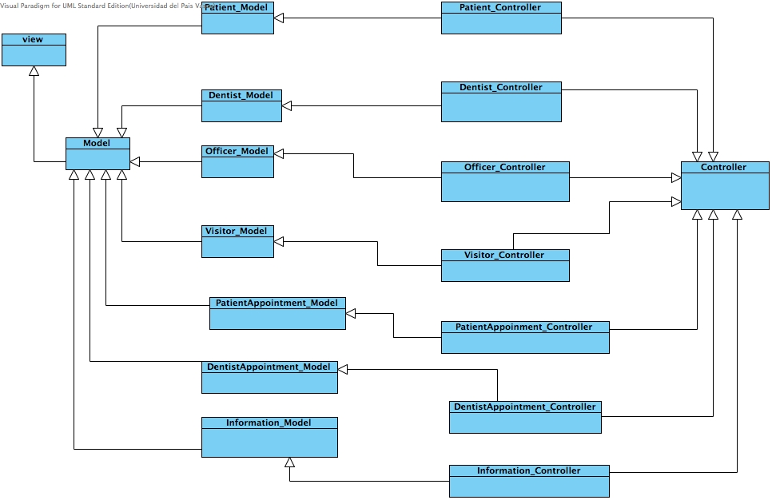

4.2 Class Diagram Description

CD-01, URS

Class name: Patient

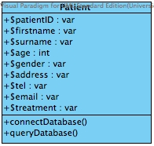

Property

|  |  |  |  |
| --- | --- | --- | --- |
| ID | Name | Description | Remark |
| 1 | $patientID | Declare variable for identify the patientID that store in the database. | Type: varchar |
| 2 | $firstname | Declare variable for identify the patients’ firstname that store in the database. | Type: varchar |
| 3 | $surname | Declare variable for identify the patients’ surname that store in the database. | Type: varchar |
| 4 | $age | Declare variable for identify the patients’ age that store in the database. | Type: int |
| 5 | $gender | Declare variable for identify the patients’ gender that store in the database. | Type: varchar |
| 6 | $address | Declare variable for identify the patient’s address that store in the database. | Type: varchar |
| 7 | $tel | Declare variable for identify the patients’ tel that store in the database. | Type: varchar |
| 8 | $email | Declare variable for identify the patients’email that store in the database. | Type: varchar |
| 9 | $treatment | Declare variable for identify the patients’ dental treatment that store in the database. | Type: varchar |

Method

|  |  |  |  |
| --- | --- | --- | --- |
| ID | Name | Description | Remark |
| 1 | connectDatabse() | Method uses to connect with the dental clinic database. | - |
| 2 | queryDatabase() | Method uses to query the data from the dental clinic database. | - |

CD-02, URS

Class name: Patient_Model

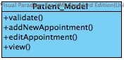

Property

|  |  |  |  |
| --- | --- | --- | --- |
| ID | Name | Description | Remark |
| - | - | - | - |

Method

|  |  |  |  |
| --- | --- | --- | --- |
| ID | Name | Description | Remark |
| 1 | validate() | Method uses to validate the input variable form patient that is format with the data in the database or not. | - |
| 2 | addNewAppointment() | Method uses to add new appointment from patient requested. | - |
| 3 | editAppointment() | Method uses to edit patients’ appointment date and time. | - |
| 4 | view() | Method uses to view any page which allow for patient | - |
| 5 | reminder() | Method uses to remind patient about his/her appointment. | - |

CD-03,URS

Class name: Patient_Controller

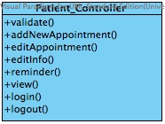

Property

|  |  |  |  |
| --- | --- | --- | --- |
| ID | Name | Description | Remark |
| - | - | - | - |

Method

|  |  |  |  |
| --- | --- | --- | --- |
| ID | Name | Description | Remark |
| 1 | validate() | Method uses to validate the input variable form patient that is format with the data in the database or not. | - |
| 2 | addNewAppointment() | Method uses to add new appointment from patient requested. | - |
| 3 | editAppointment() | Method uses to edit patients’ appointment date and time. | - |
| 4 | editInfo() | Method uses to edit patient personal information into the databse. |  |
| 5 | reminder() | Method uses remind the patient about his/her appointment | - |
| 4 | view() | Method uses to view any page which allow for patient | - |
| 10 | login() | Method uses to login using patientID and password | - |
| 11 | logout() | Method uses to logout from the system | - |

CD-04, URS

Class name: Officer

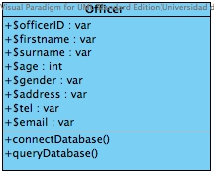

Property

|  |  |  |  |
| --- | --- | --- | --- |
| ID | Name | Description | Remark |
| 1 | $officerID | Declare variable for identify the officerID that store in the database. | Type: varchar |
| 2 | $firstname | Declare variable for identify the officers’ firstname that store in the database. | Type: varchar |
| 3 | $surname | Declare variable for identify the officers’ surname that store in the database. | Type: varchar |
| 4 | $age | Declare variable for identify the officers’ age that store in the database. | Type: int |
| 5 | $gender | Declare variable for identify the officers’ gender that store in the database. | Type: varchar |
| 6 | $address | Declare variable for identify the officers’ address that store in the database. | Type: varchar |
| 7 | $tel | Declare variable for identify the officers’ tel that store in the database. | Type: varchar |
| 8 | $email | Declare variable for identify the officers’email that store in the database. | Type: varchar |

Method

|  |  |  |  |
| --- | --- | --- | --- |
| ID | Name | Description | Remark |
| 1 | connectDatabse() | Method uses to connect with the dental clinic database. | - |
| 2 | queryDatabase() | Method uses to query the data from the dental clinic database. | - |

CD-05,URS

Class name: Officer_Model

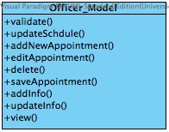

Property

|  |  |  |  |
| --- | --- | --- | --- |
| ID | Name | Description | Remark |
| - | - | - | - |

Method

|  |  |  |  |
| --- | --- | --- | --- |
| ID | Name | Description | Remark |
| 1 | validate() | Method uses to validate the input variable form officer that is format with the data in the database or not. | - |
| 2 | updateSchedule() | Method uses to update the patient and dentist schedule in the dental clinic database | - |
| 3 | addNewAppointment() | Method uses to add new appointment from patient which requested. | - |
| 4 | editAppointment() | Method uses to edit the patients’ appointment date and time. | - |
| 5 | delete() | Method uses to delete patient or dentist appointment form the database. | - |
| 6 | saveAppointment() | Method uses to save the patient and dentist appointment into the database. | - |
| 7 | addInfo() | Method uses to add personal patient information and personal dentist information. | - |
| 8 | updateInfo() | Method uses to save the patient and dentist appointment into the database. | - |
| 9 | view() | Method uses to view any page which allow for officer | - |

CD-06,URS

Class name: Officer_Controller

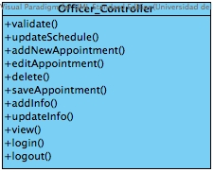

Property

|  |  |  |  |
| --- | --- | --- | --- |
| ID | Name | Description | Remark |
| - | - | - | - |

Method

|  |  |  |  |
| --- | --- | --- | --- |
| ID | Name | Description | Remark |
| 1 | validate() | Method uses to validate the input variable form officer that is format with the data in the database or not. | - |
| 2 | updateSchedule() | Method uses to update the patient and dentist schedule in the dental clinic database | - |
| 3 | addNewAppointment() | Method uses to add new appointment from patient requested. | - |
| 4 | editAppointment() | Method uses to edit the patients’ appointment date and time. | - |
| 5 | delete() | Method uses to delete patient or dentist appointment form the database. | - |
| 6 | saveAppointment() | Method uses to save the patient and dentist appointment into the database. | - |
| 7 | addInfo() | Method uses to add personal patient information and personal dentist information. | - |
| 8 | updateInfo() | Method uses to save the patient and dentist appointment into the database. | - |
| 9 | view() | Method uses to view any page which allow for officer | - |
| 10 | login() | Method uses to login using officerID and password | - |
| 11 | logout() | Method uses to logout from the system | - |

CD-07,URS

Class name: Visitor_Model

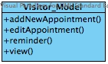

Property

|  |  |  |  |
| --- | --- | --- | --- |
| ID | Name | Description | Remark |
| - | - | - | - |

Method

|  |  |  |  |
| --- | --- | --- | --- |
| ID | Name | Description | Remark |
| 1 | addNewAppointment() | Method uses to add new appointment from patient which requested. | - |
| 2 | editAppointment() | Method uses to edit the patients’ appointment date and time. | - |
| 3 | reminder() | Method uses to remind patient about his/her appointment. | - |
| 4 | view() | Method uses to view any page which allow for officer | - |

CD-08,URS

Class name: Visitor_Controller

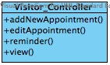

Property

|  |  |  |  |
| --- | --- | --- | --- |
| ID | Name | Description | Remark |
| - | - | - | - |

Method

|  |  |  |  |
| --- | --- | --- | --- |
| ID | Name | Description | Remark |
| 3 | addNewAppointment() | Method uses to add new appointment from patient which requested. | - |
| 4 | editAppointment() | Method uses to edit the patients’ appointment date and time. | - |
| 5 | reminder() | Method uses to remind patient about his/her appointment. | - |
| 9 | view() | Method uses to view any page which allow for officer | - |

CD-09,URS

Class name: Dentist

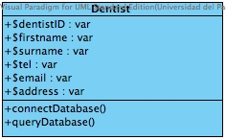

Property

|  |  |  |  |
| --- | --- | --- | --- |
| ID | Name | Description | Remark |
| 1 | $dentistID | Declare variable for identify the dentistID that store in the database. | Type: varchar |
| 2 | $firstname | Declare variable for identify the dentists’ firstname that store in the database. | Type: varchar |
| 3 | $surname | Declare variable for identify the dentists’ surname that store in the database. | Type: varchar |
| 4 | $address | Declare variable for identify the dentists’ address that store in the database. | Type: varchar |
| 5 | $tel | Declare variable for identify the dentists’ tel that store in the database. | Type: varchar |
| 6 | $email | Declare variable for identify the dentists’email that store in the database. | Type: varchar |

Method

|  |  |  |  |
| --- | --- | --- | --- |
| ID | Name | Description | Remark |
| 1 | connectDatabse() | Method uses to connect with the dental clinic database. | - |
| 2 | queryDatabase() | Method uses to query the data from the dental clinic database. | - |

CD-10,URS

Class name: Dentist_Model

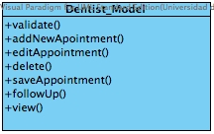

Property

|  |  |  |  |
| --- | --- | --- | --- |
| ID | Name | Description | Remark |
| - | - | - | - |

Method

|  |  |  |  |
| --- | --- | --- | --- |
| ID | Name | Description | Remark |
| 1 | validate() | Method uses to validate the input variable form officer that is format with the data in the database or not. | - |
| 2 | addNewAppointment() | Method uses to add new appointment from patient, requested and make new appointment. | - |
| 3 | editAppointment() | Method uses to edit the patients’ appointment date and time or dentist appointment. | - |
| 4 | delete() | Method uses to delete patient or dentist appointment form the database. | - |
| 5 | saveAppointment() | Method uses to save the patient and dentist appointment into the database. | - |
| 6 | followUp() | Method uses to followup dental clinics’ patient depends on the person dental treatment. | - |
| 7 | view() | Method uses to view any page which allow for dentist. | - |

CD-11,URS

Class name: Dentist_Controller

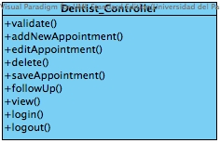

Property

|  |  |  |  |
| --- | --- | --- | --- |
| ID | Name | Description | Remark |
| - | - | - | - |

Method

|  |  |  |  |
| --- | --- | --- | --- |
| ID | Name | Description | Remark |
| 1 | validate() | Method uses to validate the input variable form officer that is format with the data in the database or not. | - |
| 2 | addNewAppointment() | Method uses to add new appointment from patient, requested and make new appointment. | - |
| 3 | editAppointment() | Method uses to edit the patients’ appointment date and time or dentist appointment. | - |
| 4 | delete() | Method uses to delete patient or dentist appointment form the database. | - |
| 5 | saveAppointment() | Method uses to save the patient and dentist appointment into the database. | - |
| 6 | followUp() | Method uses to followup dental clinics’ patient depends on the person dental treatment. | - |
| 7 | view() | Method uses to view any page which allow for dentist. | - |
| 8 | login() | Method uses to login using dentistD and password | - |
| 9 | logout() | Method uses to logout from the system | - |

CD-12,URS

Class name: Information

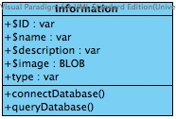

Property

|  |  |  |  |
| --- | --- | --- | --- |
| ID | Name | Description | Remark |
| 1 | $ID | Declare variable for identify the information ID that store in the database. | Type:varchar |
| 2 | $name | Declare variable for identify the information name(topic) that store in the database. | Type:varchar |
| 3 | $description | Declare variable for identify the information description that store in the database. | Type:varchar |
| 4 | $image | Declare variable for identify the information image that store in the database. | Type:BLOB |
| 5 | $type | Declare variable for identify the information type that store in the database. | Type:varchar |

Method

|  |  |  |  |
| --- | --- | --- | --- |
| ID | Name | Description | Remark |
| 1 | connectDatabse() | Method uses to connect with the dental clinic database. | - |
| 2 | queryDatabase() | Method uses to query the data from the dental clinic database. | - |

CD-13,URS

Class name: Information_Model

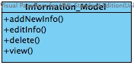

Property

|  |  |  |  |
| --- | --- | --- | --- |
| ID | Name | Description | Remark |
| - | - | - | - |

Method

|  |  |  |  |  |
| --- | --- | --- | --- | --- |
| ID | Name | Description | | Remark |
| 1 | addNewAppointment() | Method uses to add new appointment from patient, requested and make new appointment. | | - |
| 2 | editAppointment() | Method uses to edit the patients’ appointment date and time or dentist appointment. | | - |
| 3 | delete() | Method uses to delete patient or dentist appointment form the database. | | - |
| 4 | view() | | Method uses to view any information page. | - |

CD-14,URS

Class name: Information_Controller

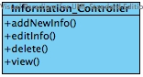

Property

|  |  |  |  |
| --- | --- | --- | --- |
| ID | Name | Description | Remark |
| - | - | - | - |

Method

|  |  |  |  |  |
| --- | --- | --- | --- | --- |
| ID | Name | Description | | Remark |
| 1 | addNewAppointment() | Method uses to add new appointment from patient, requested and make new appointment. | | - |
| 2 | editAppointment() | Method uses to edit the patients’ appointment date and time or dentist appointment. | | - |
| 3 | delete() | Method uses to delete patient or dentist appointment form the database. | | - |
| 4 | view() | | Method uses to view any information page. | - |

CD-15,URS

Class name: PatientAppointment

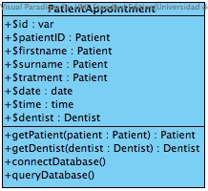

Property

|  |  |  |  |
| --- | --- | --- | --- |
| ID | Name | Description | Remark |
| 1 | $id | Declare variable for identify the patient appointment id that store in the database. | Type: varchar |
| 2 | $patientID | Declare variable for identify the patients’ id that store in the database. | Type:varchar |
| 2 | $firstname | Declare variable for identify the patients’ firstname that store in the database. | Type: Patient |
| 3 | $surname | Declare variable for identify the patients’ surname that store in the database. | Type: Patient |
| 4 | $treatment | Declare variable for identify the patients’ dental treatment that store in the database. | Type: Patient |
| 5 | $date | Declare variable for identify the patients’ appointment date that store in the database. | Type: date |
| 6 | $time | Declare variable for identify the patient’s appointment time that store in the database. | Type: time |
| 7 | $dentist | Declare variable for identify the dentist that store in the database. | Type: Dentist |

Method

|  |  |  |  |
| --- | --- | --- | --- |
| ID | Name | Description | Remark |
| 1 | getPateint($pateint:Pateint) | Method uses to get information from Patient class | Type:Pateint |
| 2 | getDentist($dentist:Dentist) | Method uses to get information from Patient class | Type:Dentist |
| 3 | connectDatabse() | Method uses to connect with the dental clinic database. | - |
| 4 | queryDatabase() | Method uses to query the data from the dental clinic database. | - |

CD-16,URS

Class name: PatientAppointment_Model

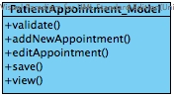

Property

|  |  |  |  |
| --- | --- | --- | --- |
| ID | Name | Description | Remark |
| - | - | - | - |

Method

|  |  |  |  |
| --- | --- | --- | --- |
| ID | Name | Description | Remark |
| 1 | validate() | Method uses to validate the input variable form patient that is format with the data in the database or not. | - |
| 2 | addNewAppointment() | Method uses to add new appointment from patient requested. | - |
| 3 | editAppointment() | Method uses to edit patients’ appointment date and time. | - |
| 4 | save() | Method uses to save the information into the database | - |
| 5 | view() | Method uses to view any page which allow for patient | - |

CD-017,URS

Class name: PatientAppointment_Controller

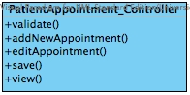

Property

|  |  |  |  |
| --- | --- | --- | --- |
| ID | Name | Description | Remark |
| - | - | - | - |

Method

|  |  |  |  |
| --- | --- | --- | --- |
| ID | Name | Description | Remark |
| 1 | validate() | Method uses to validate the input variable form patient that is format with the data in the database or not. | - |
| 2 | addNewAppointment() | Method uses to add new appointment from patient requested. | - |
| 3 | editAppointment() | Method uses to edit patients’ appointment date and time. | - |
| 4 | save() | Method uses to save the information into the databse | - |
| 5 | view() | Method uses to view any page which allow for patient | - |

CD-018,URS

Class name: DentistAppointment

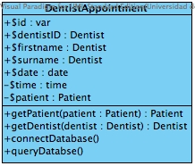

Property

|  |  |  |  |
| --- | --- | --- | --- |
| ID | Name | Description | Remark |
| 1 | $id | Declare variable for identify the dentist appointment id that store in the database. | Type: varchar |
| 2 | $dentistID | Declare variable for identify the dentist’ id that store in the database. | Type: Dentist |
| 2 | $firstname | Declare variable for identify the dentists’ firstname that store in the database. | Type: Dentist |
| 3 | $surname | Declare variable for identify the dentists’ surname that store in the database. | Type: Dentist |
| 5 | $date | Declare variable for identify the dentists’ appointment date that store in the database. | Type: date |
| 6 | $time | Declare variable for identify the dentists’s appointment time that store in the database. | Type: time |
| 7 | $patient | Declare variable for identify the patient that store in the database. | Type: Patient |

Method

|  |  |  |  |
| --- | --- | --- | --- |
| ID | Name | Description | Remark |
| 1 | getPateint($pateint:Pateint) | Method uses to get information from Patient class | Type:Pateint |
| 2 | getDentist($dentist:Dentist) | Method uses to get information from Patient class | Type:Dentist |
| 3 | connectDatabse() | Method uses to connect with the dental clinic database. | - |
| 4 | queryDatabase() | Method uses to query the data from the dental clinic database. | - |

CD-019,URS

Class name: DentistAppointment_Model

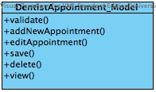

Property

|  |  |  |  |
| --- | --- | --- | --- |
| ID | Name | Description | Remark |
| - | - | - | - |

Method

|  |  |  |  |
| --- | --- | --- | --- |
| ID | Name | Description | Remark |
| 1 | validate() | Method uses to validate the input variable form dentist that is format with the data in the database or not. | - |
| 2 | addNewAppointment() | Method uses to add new appointment from dentist makeing. | - |
| 3 | editAppointment() | Method uses to edit patients’ appointment date and time. | - |
| 4 | save() | Method uses to save the information into the database | - |
| 5 | view() | Method uses to view any page which allow for patient | - |

CD-020,URS

Class name: DentistAppointment_Controller

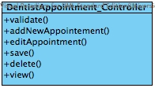

Property

|  |  |  |  |
| --- | --- | --- | --- |
| ID | Name | Description | Remark |
| - | - | - | - |

Method

|  |  |  |  |
| --- | --- | --- | --- |
| ID | Name | Description | Remark |
| 1 | validate() | Method uses to validate the input variable form dentist that is format with the data in the database or not. | - |
| 2 | addNewAppointment() | Method uses to add new appointment from dentist makeing. | - |
| 3 | editAppointment() | Method uses to edit dentists’ appointment date and time. | - |
| 4 | save() | Method uses to save the information into the database | - |
| 5 | view() | Method uses to view any dentist schedule. | - |